5 Image Statistics Analysis

To understand the characteristics of different cell types in the datasets, we perform fundamental image analysis based on intensity and color distributions. Grayscale analysis provides insights into overall brightness and contrast patterns by converting RGB images to luminance values using the standard ITU-R BT.601 weighting (0.299R + 0.587G + 0.114B). Channel-specific RGB statistics reveal color variations that may be associated with different staining properties or morphological features of cell types. These basic metrics serve as a foundation for quality control, helping to identify potential imaging inconsistencies, batch effects, or significant distributional differences between classes that could inform preprocessing decisions for the CNN classifier.

5.1 Normal Cells

### RGB and Grayscale Intensity Analysis

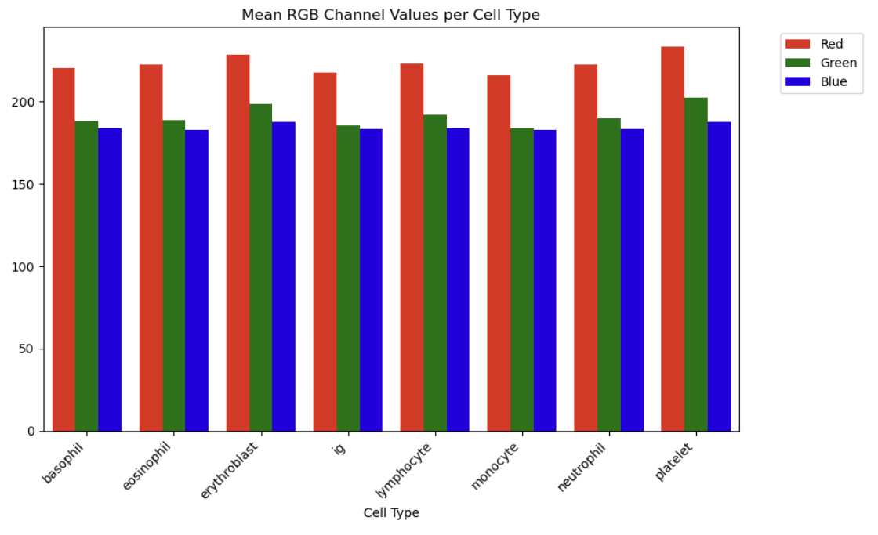

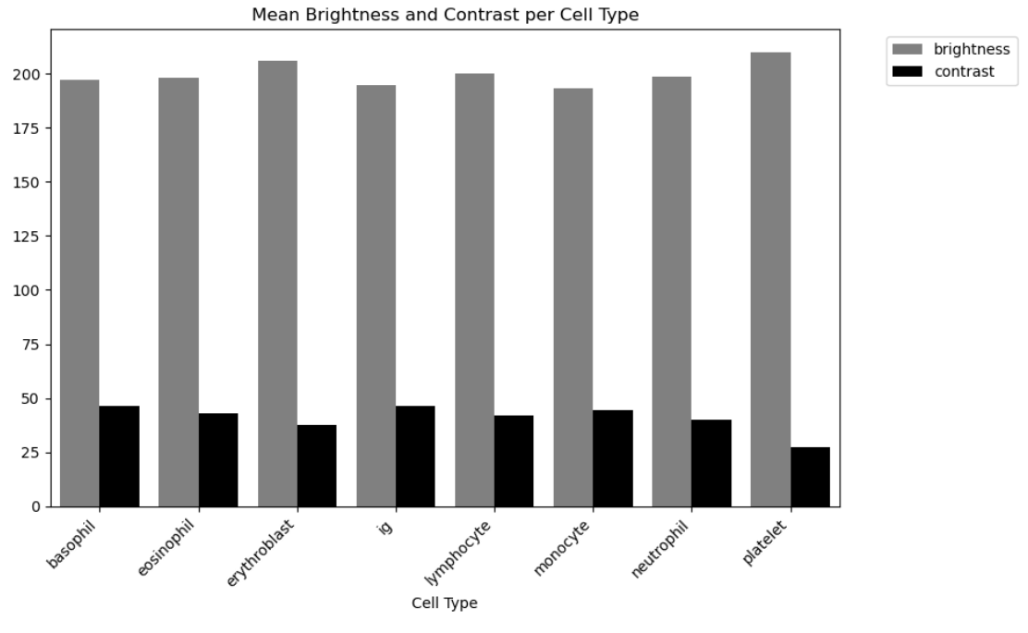

The mean RGB channel values reveal relatively consistent color profiles, with all classes showing red channel dominance (approximately 215-235) followed by green (185-202) and blue (183-190) channels. Erythroblast and platelet exhibit the highest red channel intensities (~232 and ~235 respectively), while ig displays the lowest overall intensity across all channels. The grayscale analysis demonstrates relatively uniform brightness levels (193-209) across most cell types. Platelet shows the highest mean brightness (~209) with distinctly lower contrast (~27), while ig, monocyte and basophil show slightly reduced brightness (~195-197) with higher contrast values (~47-48). Overall, the relatively narrow range of color and brightness values suggests that the CNN classifier will likely rely primarily on texture and morphological features rather than color information for differentiation.

### Distribution Analysis with Boxplots

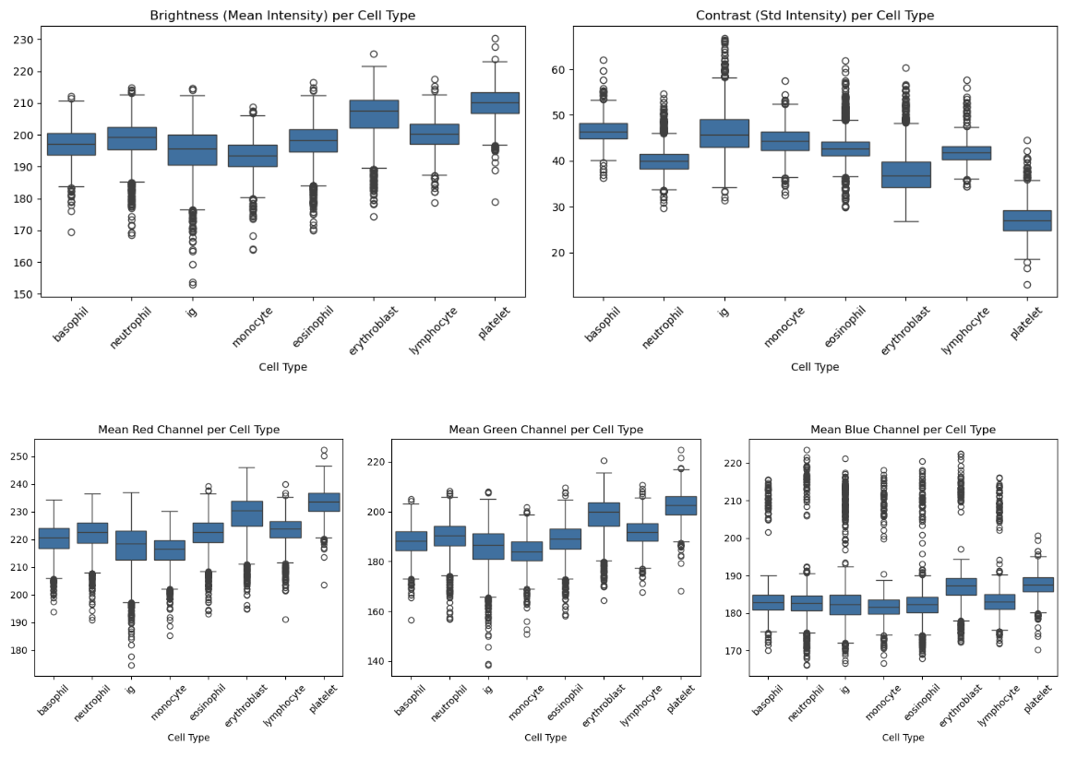

The boxplot visualizations show that most cell types display relatively compact interquartile ranges with medians around 195-210, though all classes exhibit outliers. Ig displays numerous low-intensity outliers extending down to ~155 and exceptionally high contrast variability with outliers extending above 60. Platelet demonstrates the narrowest contrast distribution with a median around 27, confirming its more homogeneous internal structure. For the RGB channels, ig exhibits numerous outliers spanning from ~175 to above 250 in the red channel, while platelet shows elevated green median values (~202). The prevalence of outliers across all metrics suggests some degree of imaging variability that could potentially be addressed through outlier filtering or normalization strategies during preprocessing.

### Conclusion

The boxplot analysis indicates that the dataset is suitable for CNN training, with most cell types displaying compact interquartile ranges and consistent median values. While outliers are present across all classes, they display consistent directionality across cell types, with outliers occurring predominantly in the same tail of the distribution. A pragmatic approach would be to proceed with training on the complete dataset and only investigate outlier filtering if specific classification problems emerge during model evaluation.

5.2 Leukemia Cells (AML)

### RGB and Grayscale Intensity Analysis

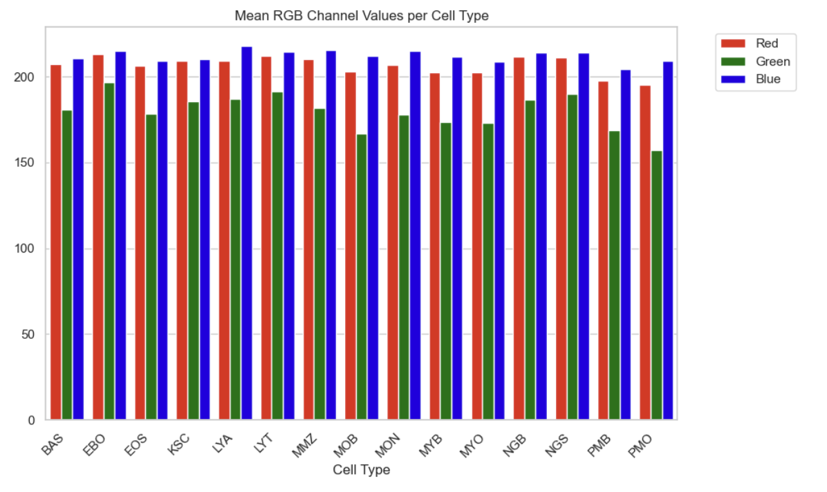

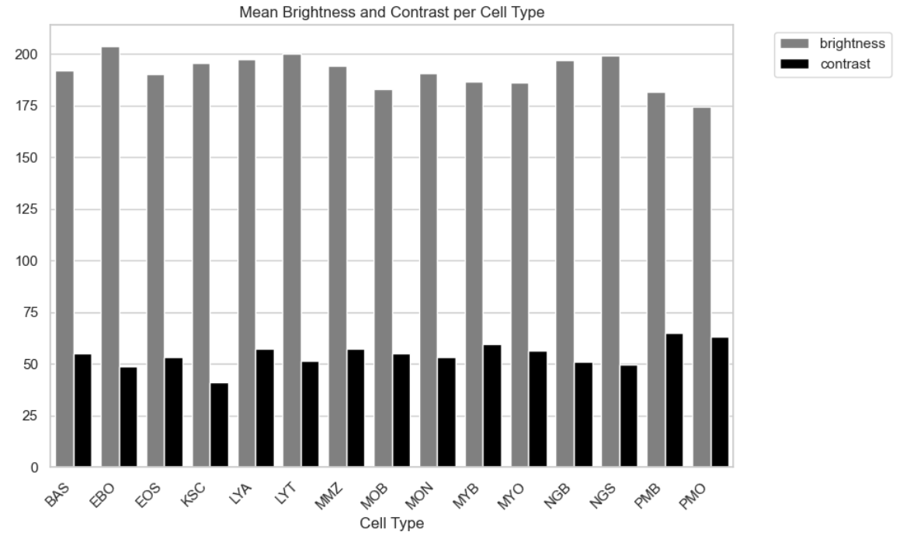

The mean RGB channel values show consistent patterns, with red values clustering around 200-210, green at 155-195, and blue at 205-220. The red channel dominance observed in the first dataset is less pronounced here, with blue channel intensities elevated. The grayscale brightness analysis reveals moderate variation (175-205) across cell types. PMO shows notably lower brightness values (< 175), while EBO exhibits higher brightness (> 200). Contrast values are relatively uniform (approximately 40-60), with KSC displaying the lowest contrast (~40) and PMO and PMB showing elevated levels (~65). Overall, the dataset displays greater variability in brightness and color profiles compared to the first dataset, which may provide more discriminative features for CNN classification, though it could also indicate greater imaging heterogeneity.

### Distribution Analysis with Boxplots

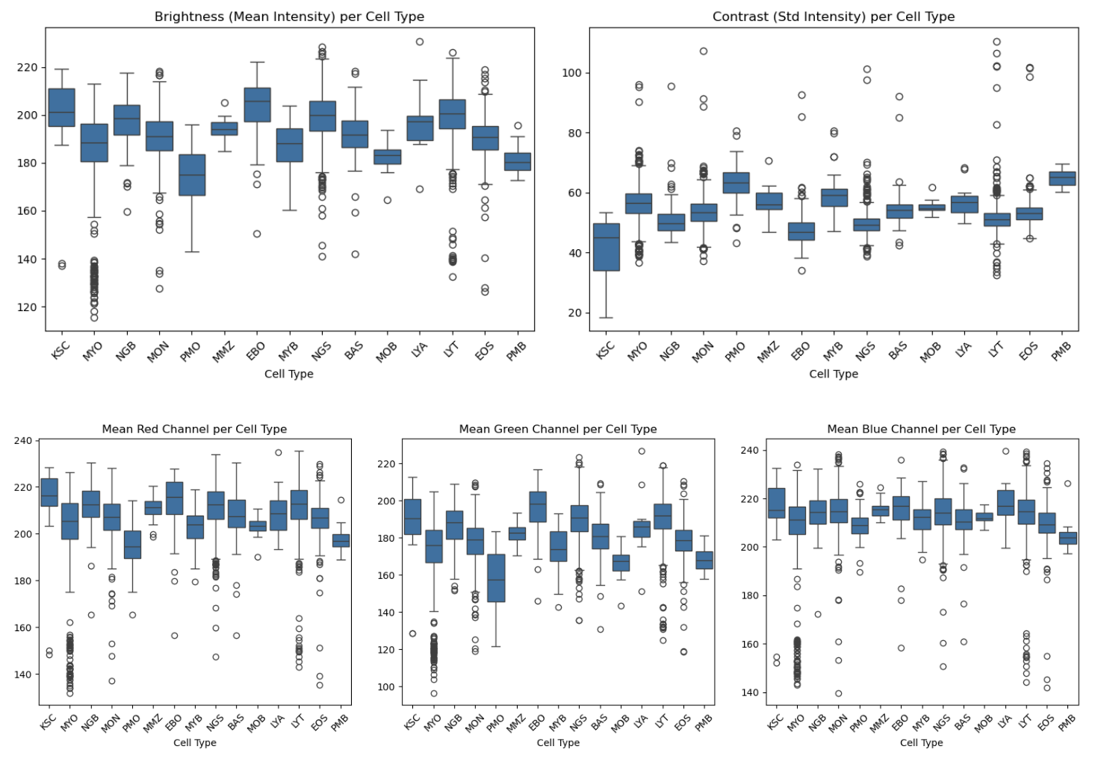

The boxplot visualizations reveal substantial variability and extensive outlier patterns. MYO exhibits an exceptionally wide brightness range with outliers extending from approximately 115 to 140, indicating severe imaging inconsistencies. KSC, LYT and MON also display considerable spread with low-intensity outliers. The contrast distribution shows that LYT has an extremely broad range spanning from approximately 30 to over 110. For the RGB channels, all three exhibit extensive outlier populations. The prevalence and severity of outliers is substantially greater than in the first dataset and suggests the need for quality control measures before CNN training.

### Conclusion

The analysis reveals that this dataset exhibits significantly greater heterogeneity and imaging variability compared to the first dataset, with several classes (particularly KSC, MYO, and PMO) showing extensive outlier populations. The extreme outliers observed - especially in MYO with brightness values ranging from ~115 to over 210 - may indicate potential data quality issues. From a pragmatic perspective, CNN training can proceed with the complete dataset initially, but if classification problems emerge for these outlier-prone classes, implementing quality control filtering (e.g., removing images beyond 1.5× IQR) could improve model performance.

